*Wind Energy Module*

# **Module Summary**

Students will learn the importance of adapting quickly to inevitable constraints in a team setting. Through the different scenarios students will expand their creativity in the engineering design process. Moreover, this activity will introduce students to the concept of harnessing the power of the wind for energy and common problems associated with wind turbines. To begin, students will be introduced to the concept of wind energy and then move into the hands on project. For the project, students will build a windmill in teams with supplies such as foam core, cardboard, construction paper, duct tape, popsicle sticks, etc. They will be given an initial task of building a windmill that will turn in the wind. Periodically throughout the activity, new constraints will be introduced to simulate real problems with windmills. For example, some constraints will include taking away materials to build with because they are now too expensive. Students will need to think quickly and use available resources to accommodate their projects to these restrictions. At the end of the module students will present their windmills to the group in 1 minute pitches and reflect in small groups.

# **Learning Outcomes**

* Students will be introduced to wind energy and learn about the ways to harness and use wind energy
* Students will learn to use common materials to make useful products
* Students will be introduced to the concept of converting mechanical energy to electrical energy
* Students will understand that everyone can be an engineer
* Students will practice making adjustments to projects based on user needs
* Students will learn how to communicate about STEAM projects

|  |  |  |  |  |
| --- | --- | --- | --- | --- |
| Activity | Time | Objective | Goal | PD |
| Introduction and Pre Evaluation |  |  |  |  |
| Wind Presentation and Pinwheel Activity |  |  |  |  |
| Introduce Task & Brainstorm in teams |  |  |  |  |
| Build Phase |  |  |  |  |
| Team Pitches |  |  |  |  |
| Reflection and Post Questionnaire |  |  |  |  |

# **Timeline**

0:00 - 0:05 | Introductions and pre evaluation

0:05 - 0:20 | Wind Presentation and Activity

Introduction to wind ([powerpoint presentation](https://docs.google.com/presentation/d/1GoPSyebgX-OEAK4Ofr9BAZVuMeTtO7sFR4v9YkXHbAQ/edit?usp=sharing)): what it is, where it is, and what causes it. Use a fan to have students experience changes in wind strength based on distance from the fan, angle that the wind hits them, and when objects are in the way of air flow. Students will have pinwheels which they can use to visibly see the differences in wind strength as the different variables (angle, distance from fan, etc) change.

0:20 - 0:40 | Introduce Task

Split up into teams. Teams will brainstorm what is the main problem and potential ways to solve the problem. There will be no building in this time period.

0:40 - 1:20 | Students build wind turbines in teams of 5 (without motorized component)

* Students will have materials for use, and due to the “everyday” nature of the materials, we are restricted in the size of the final product (paper tubes, popsicle sticks, etc.)
* The focus for the students will be on gaining hands on experience designing and fabricating the product, making mistakes along the way is part of the learning process

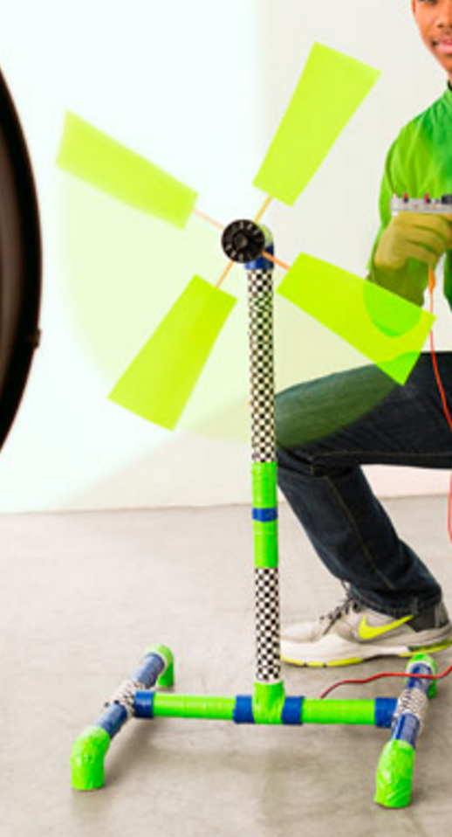

1:20 - 1:40 | Students will pitch their wind turbines to the group in 2 minute pitches. This will simulate pitches to investors of the wind turbine and we will give the following points that they must mention:

* Talk about impact on community
* Justify design decisions in context of specific problem statement
* Explain the aesthetic aspects

1:40 - 1:50 | Students will reflect on the activity in small groups, talking about what specific parts they enjoyed, thought were challenging, and what parts they think they did well in

1:50 - 2:00 | Students will clean up their areas

2:00 - 2:20 | Students will experiment and interact with a pre-made wind turbine that lights up an LED to understand how mechanical energy is transformed into electrical energy

* We will pre-construct 8 model wind turbines that light up an LED for students to experiment with. Each classroom of 25 students will have one wind turbine. The design for the wind turbine will be based off of [this website](https://www.exploratorium.edu/snacks/light-wind).

2:20 - 2:30 | Students will fill out the post evaluation questionnaire and teachers will provide final thoughts

# **Evaluation Criteria**

Students will be given a questionnaire before and after the module.

Pre survey/Post survey:

* What is wind energy? What are ways to use wind energy?
  + Success if post survey explains the concept of wind energy and how to use it.
* What materials do you use in engineering?
  + Success if everyday materials are named in post survey that were not mentioned in pre survey
* What are everyday materials you can engineer?
  + Success if students list more things in post survey compared to pre survey

# **Considerations for different aged children**

Older students:

Older students will be taught more technical information in the wind lesson. We will talk about how changes in pressure and heat cause wind, and also discuss the Beaufort scale. We will incorporate more graphs and tables that the students will need to interpret for themselves, such as world maps of wind intensity during different times of year and diagrams of air flow. In addition, there will be a more in-depth explanation of wind turbines and specifically how energy is generated using propellers, generator, and electromagnetic induction.

Younger students:

For younger students, there will be a greater emphasis on the interactive activity, as we feel that this will facilitate students’ understanding of wind better. We will encourage students to think of examples from their lives related to wind. We want to make sure the students are able to have fun while learning about wind.

# **Recommendations for Teachers**

* Don’t limit the students creativity
* Encourage teachers to do a hands-on activity following an informative lesson on a concept to ensure that students fully grasp the lesson
* Strategies for helping students practice flexibility and quick-thinking in design
* Discuss strategies for ensuring that groups work together effectively, and each student is able to contribute

# **Relevance to pK-12 Action Group**

This module introduces the concept of wind energy and iterative design in a fun, interactive, and hands on approach that embodies the *Mens et Manus* MIT philosophy. Through designing windmills, students will be introduced to the concept of wind energy as a form of renewable energy. By using everyday materials, students will learn that they can engineer anywhere and that high impact projects can also have low costs. With the introduction of different scenarios, students will learn how to quickly adapt to real and relevant problems in the wind energy business. Moreover, the module teaches the importance of working together as students will work in teams. Emphasizing the power of teams, this module embraces MIT’s focus on collaboration. The 1 minute pitches in teams allow the students to have experience presenting their work which highlights the importance of articulating STEAM work concisely and effectively.

The lessons taught in this module are essential skills for a career in STEAM. With the funding for this module, the valuable lessons taught in this lesson will not only be shared with the CIS, but also educators and students around the world.